1st prize winner Jessica Pandian (LSE)

Colombian Women in London. Shaping Collective Memory through Art in the Post-Conflict Era. By Jessica Pandian

Colombia has endured one of the lengthiest periods of internal political violence in the modern world (Sanín et al., 2007). The 52 yearlong armed conflict began in 1964 and formally ended in 2016, with the signing of a peace accord between the Colombian government and the Fuerzas Armadas Revolucionarias de Colombia (FARC) (Segura and Mechoulan, 2017). The dispute was characterized by extensive violence and the multiplicity of actors involved, namely the Colombian government, paramilitaries, crime syndicates and leftist guerillas (Bouvier, 2009; Meltzer and Rojas, 2005).
Over the course of the armed conflict 218, 000 people were killed. Moreover, 25,000 people were forcibly disappeared and an innumerable number of women were subject to sexual violence (Grupo de Memoria Histórica, 2013). In this context of intense violence and insecurity, the armed conflict generated mass transnational migration. The first wave of Colombian migration to London occurred in the 1960s and was comprised primarily of exiles fleeing from political violence. Into the 1990s, the armed conflict intensified, and Colombian migration increased as Colombians came to the UK in search of asylum (McIlwaine, 2014; Cock, 2011). In 2011, 19,338 Colombians were registered as residing in London (Office for National Statistics, 2011).
In order to address its brutal past and to forge a peaceful future ahead, Colombia and its diaspora have embarked on the task of constructing its collective memory (Conciliation Resources, 2017). Collective memory can be described as a groups’ (for example, a nation) recollection of the past through the lens of the present, which involves the selective and continual process through which these collectives contrive meaning from the past (Tenenboim-Weinblatt and Baden, 2016; Ring et al., 2017). Accordingly, this research investigated how Colombian women of the diaspora in London influence collective memory in the post-conflict era from a gendered perspective, using artistic methods and expression as a vehicle.

For this research I worked with the ‘Truth, Memory and Reconciliation Commission of Colombian Women in the Diaspora’ (TMRC) over 6 months. Participant observation and textual analysis (of music, musical texts, images and theatrical performances) formed the core methodological approaches for this research.

I divided my research into 3 key artistic themes, with the first theme focussing on how the visual arts were used to harness the idea of collective memory. As part of this, I visited the ‘Imagine Peace’ photography exhibition which presented approximately 20 portraits of women from the TMRC alongside their written testimonies.

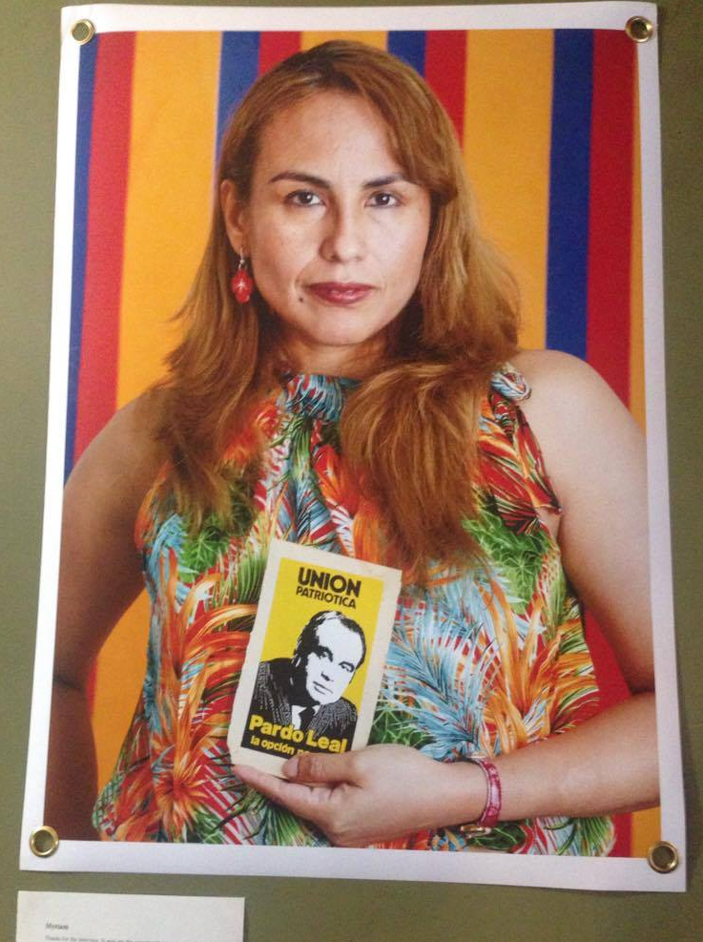
This portrait of Myriam was part of the exhibition and was taken by Ingrid Guyon (2017). It is particularly captivating because of the boldness and multiplicity of the colours it displays. Behind her are the colours of the Colombian flag, which serve to anchor Myriam to Colombia. The Colombian flag colours act as a binding force between Colombian women in the diaspora, thus articulating the group identity through which recollection of the past can take place in a striking and instantly recognisable way (Halbwachs, 1992; Solso, 1996).

Furthermore, in the written testimony Myriam explains that the Unión Patriotica (UP - a leftist Colombian party founded by the FARC and the Colombian communist party) poster symbolises to her the murder of Jaime Pardo Leal (a candidate of the UP Party for the presidency of Colombia) and the genocide of 4000 leaders of the UP. Therefore, the strategic decision to present this poster and frame it from the perspective of injustice leads to greater recognition of such events and foments processes of ‘justice as recognition’ and ‘truth-telling which are integral to collective memory (Allen, 1999; Jelin, 2003; Bietti, 2009; Valkanova, 2010).

The second point of analysis centred on the meanings found in particular lyrics, songs and musical performances (Revill, 2010). The first musical performance I witnessed occurred just after a participatory talk organised by the TMRC between approximately 20 Colombian women. The talk touched upon the women’s memories and perspectives of the Colombian conflict, thus framing the context for the singing performance.

The first song sung was ‘El Reloj de Campana’ (The Bell Clock). The lyrics of the song clearly speak to women’s empowerment, “Reloj de campana tócame las horas/ Para que despierten las mujeres todas/ Porque si despiertan todas las mujeres/ Irán recobrando sus grandes poderes” (Bell Clock, ring/ So that all the women wake up/ Because if all the women wake up/ They will regain their great powers). The lyrics portray women as untapped potential, thus presenting them as agentic and instrumental change makers (Van Dijck, 2006). Consequently, the meanings in this song can help to restore confidence and self-esteem lost during periods of conflict and migration and can challenge feelings of victimisation and powerlessness that the women experienced in the past (de Brito et al., 2001). The song can be interpreted to mean that women need to ‘wake up’ and recognise their importance in the construction of collective memory.
Accordingly, music can be seen to reify women’s importance and self-worth, meaning that they were more likely to contribute to the task of collective memory. Moreover, through metaphorical lyricism, music was able to establish strong emotional and symbolic ties to Colombia among the women of the diaspora, thus facilitating the bolstering of group identity through their mutual connection as diaspora.

The third aspect of my research of my research focussed on the theatrical representation of testimony. For this, I watched a monologue by Colombian actress Alejandra Borerro, which related the testimony of Ana Victoria (part of TMRC). The testimony described how traffickers subjected Ana Victoria to torture and sexual violence whilst she was searching for an indigenous young girl whom she suspected of being trafficked from her own indigenous community. The girl was never found, and Ana Victoria’s friend and accomplice died during the ordeal. Ana Victoria subsequently migrated to the UK. However, the monologue ends on an uplifting tone by mentioning that Ana Victoria was ordained as the first female Colombian Anglican priest.

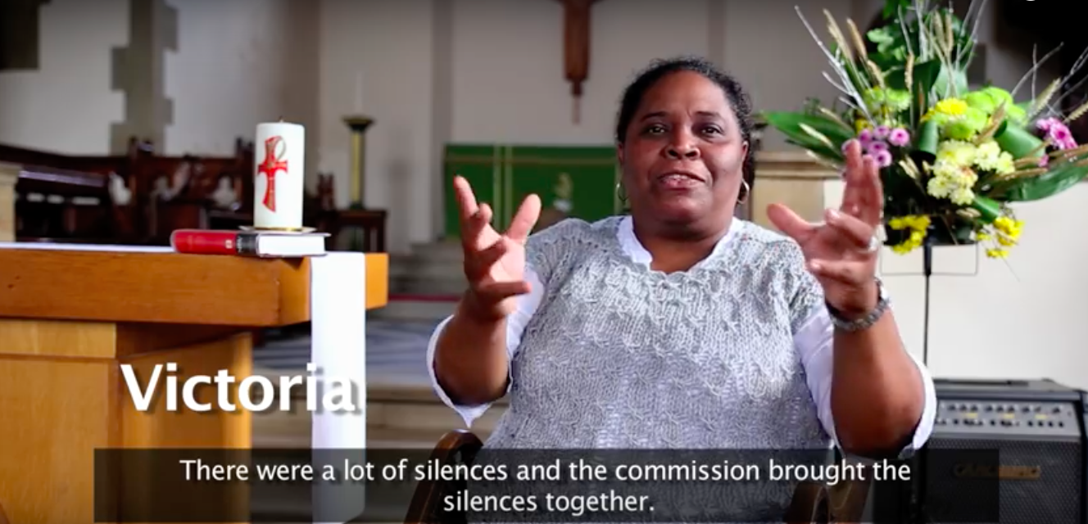
Figure 8: A screenshot of Ana Victoria speaking during the TMRC short film ‘Breaking the Silence’ (2016)
While the monologue of Ana Victoria’s testimony discussed kidnapping, trafficking, death and sexual violence, which Ephgrave (2014) argues can result in the construction of a singular woman victim (who is perceived as a monolithic subject and victim lacking any complexity and agency) it demonstrated elements of Ana Victoria’s resistance and agency. This was exhibited in the way that she “began investigating” the disappearances on her own accord; returned to the indigenous community after tense encounters with the military and insisted on meeting with the intermediary of the trafficking. Not only did the monologue draw attention to women as resistors in conflict, but as aggressors as well, through the woman who trafficked young girls from her own community. This greatly shifted the paradigm away from automatically conceiving women as victims and fostered critical consciousness about the multiple roles that women can play in conflict leading to a more nuanced and engaged collective memory (Kiguwa, 2006; Ephgrave 2014).

In conclusion, Colombian women are working to shape collective memory through the artistic methods of visual arts, music and performance. These artistic modes foment the development of a collective identity (based on their Colombian heritage, as women and as diaspora) through which collective memory can take place. Furthermore, artistic methods aided in empowering women and in articulating them as resilient, agentic and valuable in the construction of collective memory, therefore challenging dominant stereotypes of women within collective memory. Art has enabled those who are normally considered and treated as marginal to the project of collective memory to exercise their agency, to gain recognition for themselves and to fight for their inclusion and participation in the task of collective memory.

In realizing this research, I hope to have opened up the pathways for more research to be carried out on the Colombian (and more generally, Latin American) community in London. Moreover, I hope that I have consolidated the importance of analyzing art in geographical and social science study. I also hope that this research has illuminated the importance of studying women’s and diaspora’s involvement in collective memory and will encourage more researchers to explore this under-researched area.

Finally, I am truly grateful to the TMRC for allowing me to observe and be a part of their world, and also to the Gender and Feminist Geographies Group for having recognized my research.

References

Allen, J. (1999). Balancing Justice and Social Unity: Political Theory and the Idea of a Truth and Reconciliation Commission. The University of Toronto Law Journal, 49(3), pp.315.

Bietti, L. (2009). Entre la cognición política y la cognición social: El discurso de la memoria colectiva en Argentina. Discurso & Sociedad 3(1), 44-89.

Bouvier, V. (2009). Colombia: Building Peace in a Time of War. Washington: United States Institute of Peace.

Cock, J. (2011). Latin American Commercial Spaces and the Formation of Ethnic Publics in London: The Case of the Elephant and Castle. In: C. McIlwaine (Ed.). Cross-border migration among Latin Americans: European Perspectives and Beyond. Basingstoke: Palgrave Macmillan.

Conciliation Resources (2017). Pilot Phase Achievements. London: Conciliation Resources.

de Brito, A., Enriquez, C. and Aguilar, P. (2001). The Politics of Memory: Transitional Justice in Democratizing Societies. Oxford: Oxford University Press.

Ephgrave, N. (2014). Women’s testimony and collective memory: Lessons from South Africa’s TRC and Rwanda’s gacaca courts. European Journal of Women’s Studies. 22(2), pp. 177-190.

Grupo de Memoria Histórica. (2013) ¡Basta Ya! Colombia: Memorias de guerra y dignidad. Bogotá: Imprenta Nacional.

Guyon, I., 2017. Myriam. [photograph] (London, Imagine Peace Photography Exhibition).

Halbwachs, M. (1992). On Collective Memory. Chicago: University of Chicago Press.

Jelin, E. (2003). State Repression and the Labors of Memory. Minneapolis, Minnesota: University of Minnesota.

Kiguwa, P. (2006). Narratives of Gender and Identity Constructs. In: T. Shefer, F. Boonzaler and P.Kiguwa, ed., The Gender of Psychology, Cape Town: UCT Press.

McIlwaine, C. (2014). Everyday urban violence and transnational displacement of Colombian urban migrants to London, UK. Environment and Urbanization, 26(2), 417-426.

Meltzer, J. and Rojas, C. (2005). Elusive peace: international, national, and local dimensions of conflict in Columbia. New York: Palgrave Macmillan.

Office for National Statistics (2011). 2011 Census.

Revill, G. (2000). Music and the Politics of Sound: Nationalism, Citizenship, and Auditory Space. Environment and Planning D: Society and Space, 18, pp. 597-613.

Ring, M., Eyerman, R. and Madigan, T. (2017). Cultural Trauma, Collective Memory and the Vietnam War. Croatian Political Science Review, 54(1-2), pp.11-31.

Sanín, F., Acevedo, T. and Viatela, J. (2007). Violent Liberalism? State Conflict and Political Regime in Colombia, 1930-2006.

Segura, R. and Mechoulan, D. (2017). Made in Havana: How Colombia and the FARC Decided to End the War. New York: International Peace Institute.

Solso, R. (1996). Cognition and the Visual Arts. Cambridge: MIT Press.

Tenenboim-Weinblatt, K. and Baden, C. (2016). Collective Memory. In: G. Mazzoleni (Ed.), The International Encyclopedia of Political Communication. Malden, MA: Wiley Blackwell.

Valkanova, D. (2010). Images as Templates for Collective Memory: Symbolism and Performance in Iconic and Popular Photographs of Woodstock 1969, 1994 and 1999. Master of Arts. University of Oregon.

van Dijck, J. (2006). Record and Hold: Popular Music between Personal and Collective Memory. Critical Studies in Media Communication, 23(5), pp. 357-374.

